Steps for creating a new account for the Absorb LMs portal.

Go to the Absorb website: https://oregonrealtors.myabsorb.com/#/login
Click on the Browse Course icon, it will take you to the list of available courses.
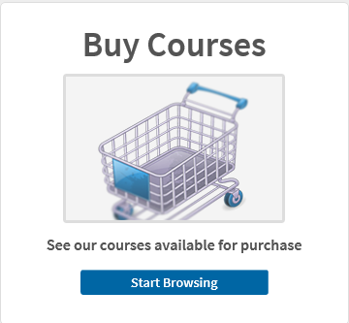

Select the courses you wish to take.
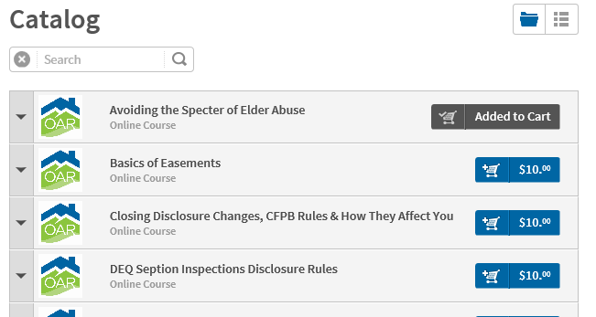

Go to your cart. The Cart icon is in the upper right-hand corner
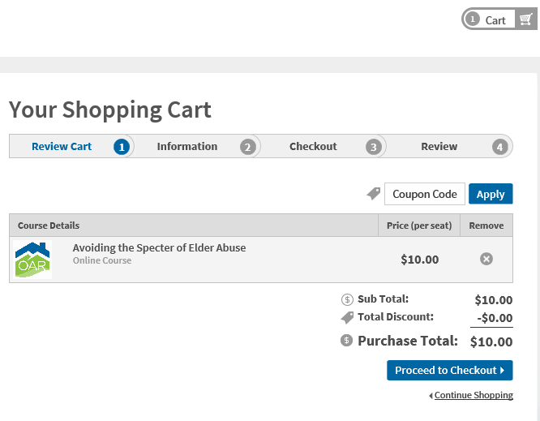
Click on Proceed to checkout and it will give you the option to login or create an account.
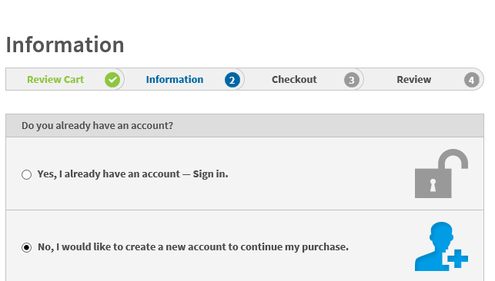
Create your account. Make sure to use a username and password you will easily remember.

